1. Consider the argument: ¬r → q, q → (r ∨ ¬q) /∴ conclusion

Which of the following conclusions make the argument valid?
work area
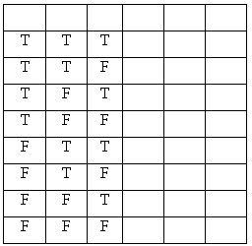
r
p ∨ r
r ∧ q
r ∧ ¬q
r ∨ (¬q ∧ p)
¬r ↔ (¬q ∨ ¬p)
(r ∧ q) ∨ (¬q ∨ r)
Which line(s) in the truth table must be true for the argument to be valid?

2. Consider the argument: p ↔ ¬q, q → r /∴ conclusion
Which of the following conclusions make the argument valid?
(p∧¬q∧r) ∨ (p∧¬q∧¬r) ∨ (¬p∧¬q∧r)
work area
r
p
¬r → ¬q
p ∨ r
(p∧¬q) ∨ (p∧¬q∧r)
Which line(s) in the truth table must be true for the argument to be valid?

Consider the argument: r ↔ ¬q, q → ¬p /∴ conclusion
Name ___________________________

Which of the following conclusions make the argument valid?
(p∧¬q∧r) ∨ (p∧¬q∧¬r) ∨ (¬p∧¬q∧r)
work area
(p∧¬q∧r) ∨ (¬p∧q∧¬r) ∨ (¬p∧¬q∧r)
r ∨ (p ∧ ¬q)
p ∧ ¬q ∧ ¬r
(¬q ∧ r) ∨ (¬p ∧ q ∧ ¬r)
(¬q ∧ r) ∨ (¬p ∧ ¬r)
Which line(s) in the truth table must be true for the argument to be valid?

4. Consider the argument: p → q, <missing hypothesis> /∴ ¬p

Which of the following statements can replace <missing hypothesis> completing the argument (i.e., makes the argument valid)?
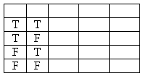
work area
p ∧ q
p ∧ ¬q
¬p ∧ q
¬p ∧ ¬q
Which values/lines must be false?

Do any values/lines have to be true?

5. Consider the argument: (p → q), r ∨ ¬q,
<missing hypothesis> /∴ (p ∨ ¬r) ↔ ¬q

Which of the following statements can replace <missing hypothesis> completing the argument (i.e., makes the argument valid)?
work area
(p∧¬q) ∨ (¬p∧¬q)
¬q
p
¬r
(¬p ∧ q) ∨ (q ∧ r)
Which values/lines must be false?

Do any values/lines have to be true?

6. Use the Venn Diagram to the right with sets X, Y and Z as shown.
The diagram has regions A, B, C, D, E, F, G and H.
Y
A
C
B
Z
X
D
E
F
G
H
List all the regions that are shaded
- 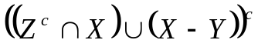

- 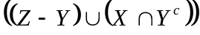

Let U = {a, b, c, d, e, f}
W = {a, b, c}
X = {b, d, e}
Y = {a, c}
Z = {a, d, e}
Ψ = Y - W^{c}
Using the above sets which of the following statements are true?
- Ψ = { }
- List all sets that are subsets of Ψ
- List all sets that are proper subsets of Ψ
- X - Z= { }
- W ∩ Y= { }
- (W ∩ Y) ∪ (X - Z) = { }

- Which of the following statements are true?
If 3 + 9 < 11 then 2 + 6 ≠ 8
If a square has more than four sides then all rectangles are squares
4 + 9 < 11 if and only if 2 + 6 = 7
If the earth revolves around the moon earth, then Mr. Madrid is from the planet Looney.
Mercury is the closest planet to the sun if and only if earth is the third planet from the sun.

14. Consider the following Conditional Propositions: (r → q) ↔ (¬r ∧ q).
Which of the following statements are true?
(r → q) ↔ ¬ (r ∨ ¬ q) is logically equivalent.
(¬r ∧ q) ↔ (¬r ∨ (r ∧ q)) is logically equivalent.
15. Consider the following Conditional Propositions: (r ↔ q) → (r ∧ ¬q).
Which of the following statements are true?
(r ∧ ¬q) → (r ↔ q) is the converse.
¬(¬r ∨ q) → (r ↔ ¬q) is the contrapositive.
(¬r ↔ q) → (r ∧ ¬q) is inverse.
Answers:

